note of web site changes. Bookie and ppg.ag
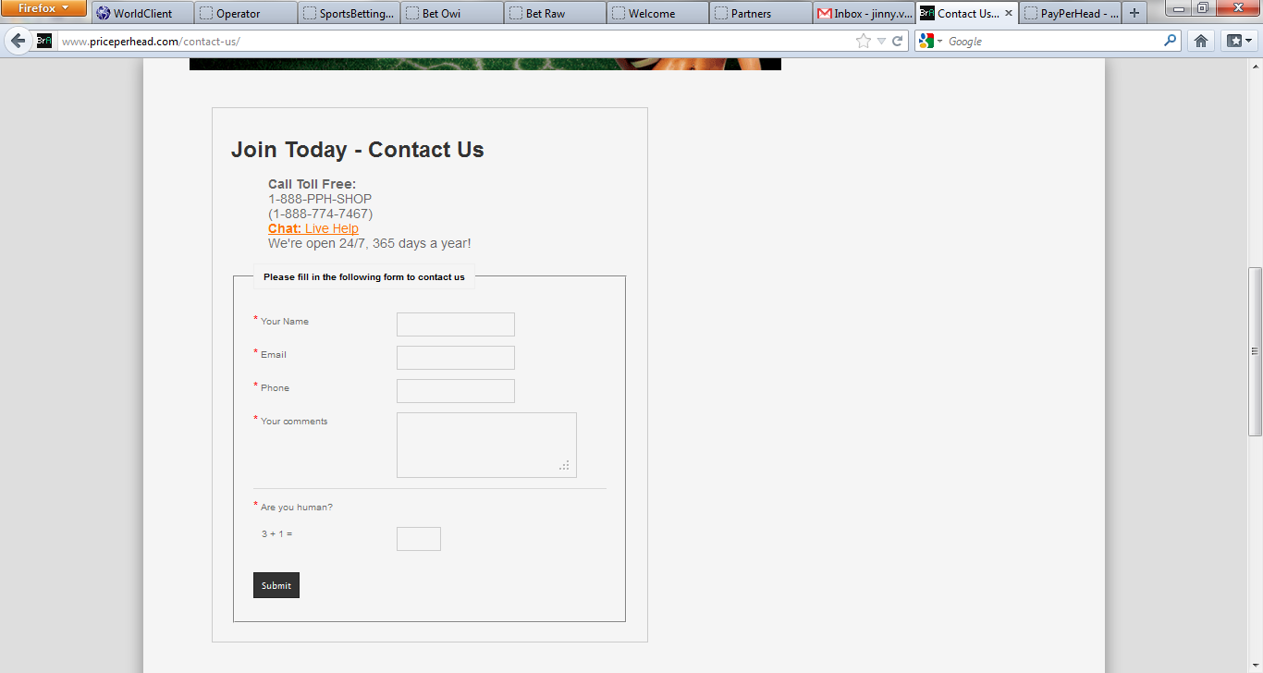
Make it wider.
Also on the bookie pph on the reports tab on the screen shots we are able to see the account names. . sbo r and so forth . If you think is possible delete the column of the player id so that way there is no mixing up between web sites and customers
Another idea for join now
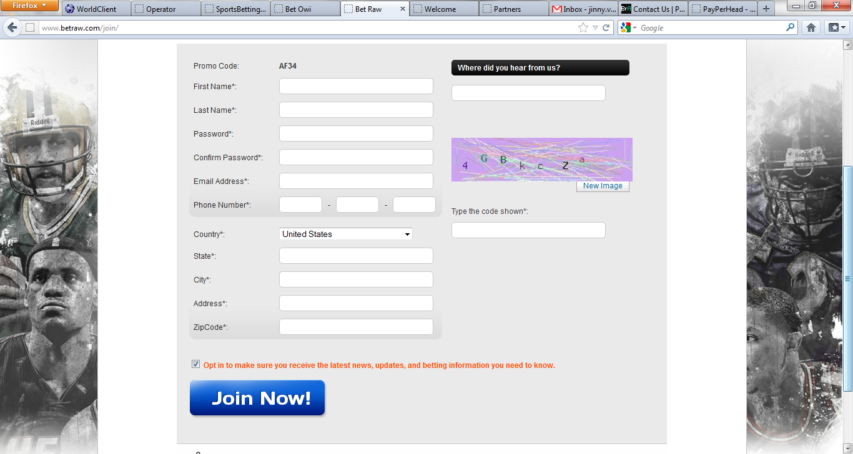
Live chat still shows the vrb marketing support
We need live chat log in for Meigan
We do not see the timing on the chat as well everything on the live chat is like one on top of the other
Sportbook TAB
All the types of bets in boxes such as :
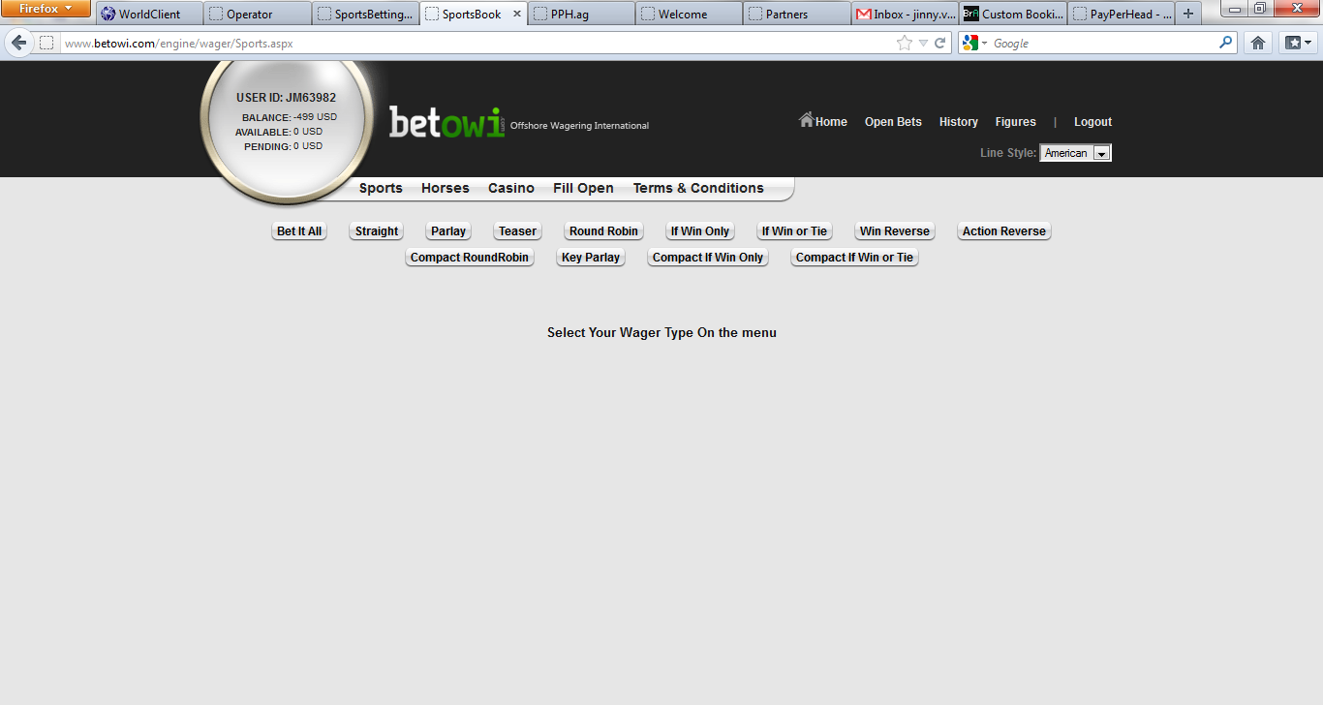
On the casino tab we need to put access to real time games once you click on it..

On the horses tab we can make the list larger instead of cutting the screen print in half
Skype Logos under our names .
For the reports page we can make it larger and wider in order to appreciate better the options for reports.
BTW on the main page of sportsbetting.ag at the bottom once you click on Bet Types Limits it will take you to another page where we have posted Sportsbettingonline.com instead of sportsbettingonline.ag

On Bet Limits and Post Times: instead of having one column with all the limits we should have them grouped by sport such as NFL then NCAA FB then NBA and so forth .. and then it says POST TIMES but there is none.

Sbo join now button is not working.

